**KPLAY오류 시 해결방법 / How to solve error for Kplay**

1. KPLAY 서버접속 / Access to the server of Kplay
2. /data/logs/weblog_해당날짜.log 확인 / Check /data/logs/weblog_해당날짜.log

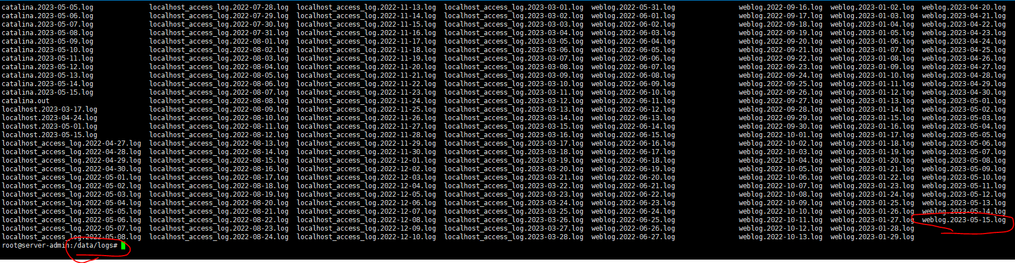

* 1. 해당 경로에 로그가 없거나 오류가 안 찍혔다면,톰캣설치경로/logs/catalina.out확인

If there is no log or error in that path, check 톰캣설치경로/logs/catalina.out



1. 만약 자바소스를 수정한다면, 서버 빌드 후 배포 (빌드&배포 방법은 2 페이지 참고)

If need to check and edit for Java source, then build the server and publish

(refer to the page #2 for the method of build and publish)

1. 서버 재기동 후 정상접속 되는지 확인 / Restart the server and check if it is working well



OR



톰캣 설치 경로는 아래 문서 참고 / Refer to the below documentation for the path of downloading Tomcat  
<https://docs.google.com/spreadsheets/d/1EFyjUsuQ1_E8qjEera4-ucpcp3FHTALUkUU4GP4FFZs/edit?pli=1#gid=2077099386>

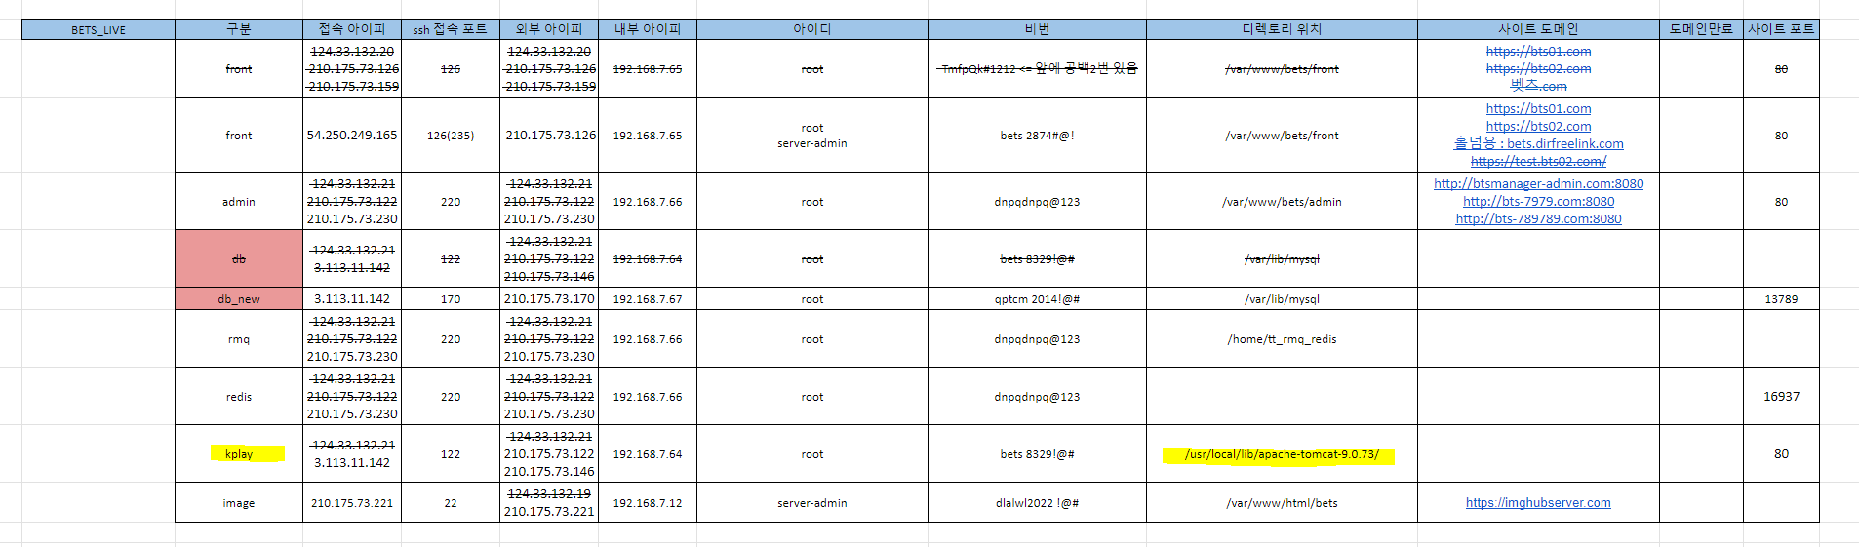

자바빌드&배포 방법 / The way of building and publishing Java

STS& LOMBOK 설치 및 세팅 작업 후 진행 / Install and setting up for STS&LOMBOK and proceed

1. bets_api프로젝트가져오기 / Bring up the project of bets_api

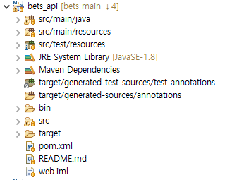

1. project 오른쪽클릭 -> Run As -> Maven build

Click right of project -> Run AS -> Maven build

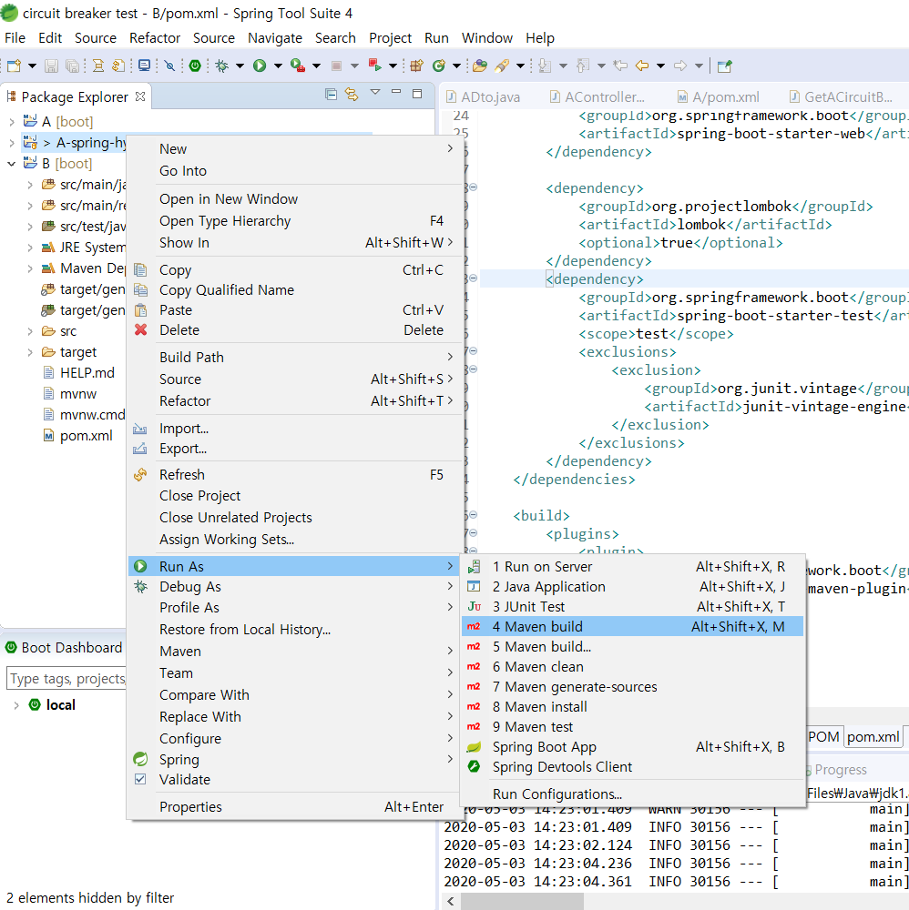

1. BUILD SUCCESS가뜨면성공 / If there is BUILD SUCCESS, then it means it is success

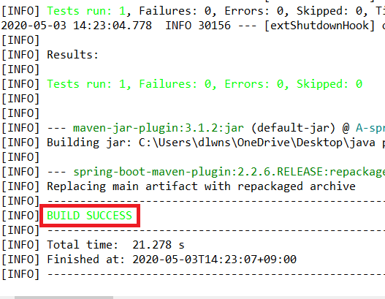

1. 소스경로/bets_api/target/ROOT.war가생성되었는지확인

Check if 소스경로/bets_api/target/ROOT.war is created.

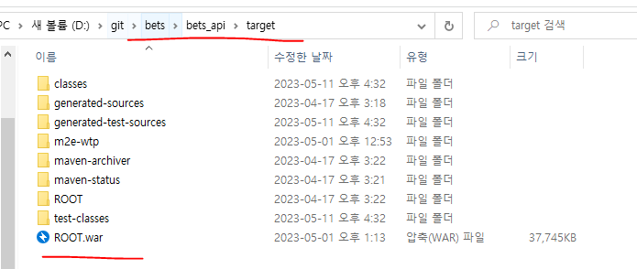

1. FTP를통해 기존WAR파일백업후신규WAR파일업로드

Upload the file of WAR after back up the new file of existing WAR through FTP  
  
/ROOT/ROOT.war  
  


OR

톰캣설치경로/webapps/○○○.war

